647 Assignment

1. First of all, search engines are remotely accessible programs that let us conduct keyword searches for information by making use of computer networks. The search is processed when we put in specific phrase, titles of documents, URL's, headers, or even full text into the search engine of our choice. Often the results we get from one search engine may not match the results from another search engine because of the way each search engine processes the information requested. For this reason, I usually tend to use more than one search engine, especially when I am doing a serious search. These days, my go to search engine is Google. I used to search with Internet Explorer, and then Mozilla Firefox. On a regular basis, I alternate between Google, Firefox and Yahoo for specific search.

Google makes searching easy for the following reasons. First, when I go to the page forms mode comes on automatically which has the focus set to a blinking cursor in an edit box. Second, it came with time-saving features such as Google Instant which could be turned on/off. This feature predicts a person's search and shows results while the person is typing his search keyword. Third, one can look for exact words in exact order by including words in quotation marks. Besides, Google isn’t case sensitive. Fourth, the “I am feeling lucky” button takes you directly to the first Web page Google returned for your query. These are, then, some of the reasons I Google most of the time.

Though it appears more cluttered than the Google, I do searches on Yahoo for specific information such as sports and news headlines and links to many other items. Regarding searches, Yahoo works very much the same way as Google.

1. There are different reasons I do searches for. Again, my choice of device depends on where I am searching. Since most businesses today are having a mobile-optimized site and my searches are driven by a need for information on the go, my phone is most available, handy and easy-to-use device.
2. Modern browsers, these days serve dual purpose when answering users' queries: display a combination of organic as well as paid (which is commonly referred to as sponsored) list of results. Organic lists are the result of the calculations that comprise a search engine's ranking algorithm and highest rank in only attained through effective search engine optimization (SEO). This is made possible through intricate ranking calculations that determine the relative relevance of the Web pages listed in the search engine's index in relation to the entered keywords along with many other factors.

On the other hand, paid search engine advertising is built around the so-called pay-per-click (PPC) concept in order to obtain a certain position in search engine listings. In other words the website owner who places the highest bid is ensured the top ranking for a certain keyword. It only depends on how much you pay for.

With over 94% of Internet users using search engines to find what they’re looking for, having an effective presence there is vital. Though it takes a lot of time and effort to develop the most relevant web presence, organic ranking is free. Moreover, I found organic results more reliable than the paid ones and most people do feel the same way.

When talking about cons of organic listing, the most important one is lack of control over the ever changing search engine result preference criteria as well as the secret formula Google uses to push your page to the top of the list. Our knowledge is limited to what Google calls “best practice”, which is not really the only thing required.

Regarding paid search traffic, the first advantage is one can have full control over  payment set up and budget how much you are going on daily basis. Similarly, you can control the type of visitors to your site making every dollar you spend more efficient. These holds true for both pay-per-click (PPC) and pay-per-thousand (CPM) plans.

The disadvantages to the paid plan is increased competition in this market has driven costs up, more so in certain markets.  Higher competition also means that those companies with big budgets and man power tend to have the dominant positions.

1. This summer, I frequently searched for keyword related to the classes I am taking. Most often, the following sites rank at the top.

www.w3schools.com

[https://forum.**jquery**.com](https://forum.jquery.com)

[www.jquerybyexample.net](http://www.jquerybyexample.net)

<https://www.sitepoint.com>

stackoverflow.com

For me, one of the reasons is their bigger brand and the resulting bigger social media reach. The second reason is that they are well-written, as are a decent number of images and strong internal links. Page load speed also is a factor, as is the word count, when it comes to backlinks. If you’re consistently publishing good content, steadily acquiring backlinks, and adding rich media including images and video, you’re taking all the right steps to maintain a solid ranking.

Definitely, whether I’m using Internet Explorer (IE), Firefox or Google Chrome, the rankings comes with drastically different search results – both in maps and organic. Google rankings change based on numerous factors – the browser being one of them. But if you log into Google while using Chrome, the results are personalized based on past search history and preferences. Being logged in is a big factor in the results, followed by location.

1. 1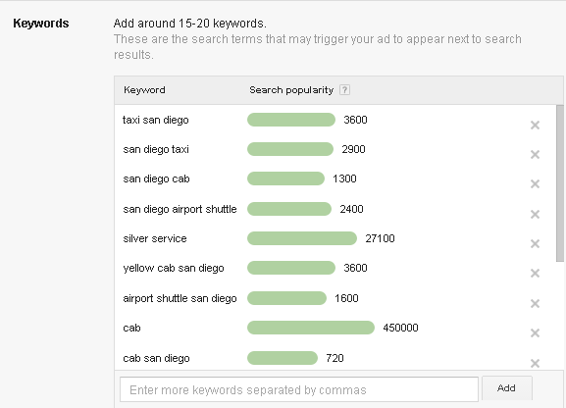

2 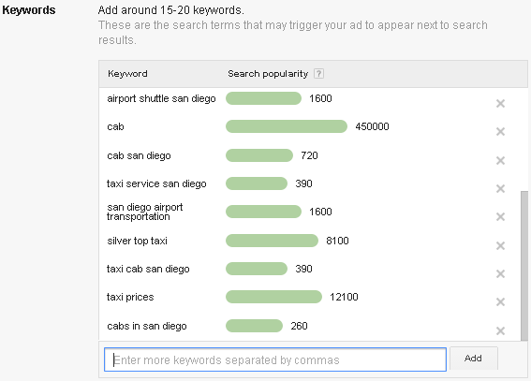

1. [www.**tutorialspoint**.com](http://www.tutorialspoint.com)

www.w3schools.com

stackoverflow.com

I usually go to these sites for information. stackoverflow.com is more of community contribution- it surely needs crosschecking. Still it is a good resource in which I get answers for all my questions. [www.w3schools.com](http://www.w3schools.com), on the other hand well-written, well-organized and easy to understand. It also has sample demo, but the content is not considerably deep. If I have to use the information from these site, I definitely, need to consult another resource. [www.**tutorialspoint**.comnd](http://www.tutorialspoint.comnd) has limited areas of explanation, but detail. I may not find answer for all coding questions; still it gives detail analysis of queries.

There simplicity is what I would like have in my site.

1. For all three scenarios, the first thing I want to fix is the form: I will simply put placeholder text instead of actual text. For international visitors, I will definitely consider putting translations of the components. Besides, there should be a separate promotion page, put appropriate text instead of the extended paragraphs on the footer area.
2. [www.**sandiego**.org](http://www.sandiego.org) <https://www.sdmts.com>

Interactive navigation interactive navigation

Overcrowded homepage good layout

No site map has site map

1. <?xml version=”1.0” encoding=”UTF-8?>

<urlset xmlns=<http://www.sitemaps.org/schemas/sitemap/0.9>>

<url>

<loc>http://www.example.com</loc>

<lastmod>2005-01-01</lastmod>

<changefreq>Monthly</changefreq>

<priority>0.8</priority>

</url>

<[url](http://www.sitemaps.org/protocol.html#urldef)>

      <[loc](http://www.sitemaps.org/protocol.html#locdef)><http://www.example.com/catalog?item=74&amp;desc=vacation_newfo> undland</loc>

      <[lastmod](http://www.sitemaps.org/protocol.html#lastmoddef)>2004-12-23T18:00:15+00:00</lastmod>

      <[priority](http://www.sitemaps.org/protocol.html#prioritydef)>0.3</priority>

</url>

</urlset>

User-agent: Google

Disallow:

User-agent: *

Disallow: /

1. Facebook , Twitter, Google+

In my opinion, getting quality social shares is ideal, but being shared widely on social networks is still helpful. Good things happen when more people see your site or brand and share it through social media. This might be because search engines don’t count all links equally.

Again, participation in social sharing sites is crucial. If you don’t have a Twitter account, a Facebook fan page or Google+ Page you’re missing out. You may not be able to sell any of your brands in the networked world. You’re not building up a network that can help spread (aka share) your content, site and brand. To conclude, you want to gain references from social accounts with good reputations. Having your own social presence that is well regarded is important. So participate on relevant social platforms in a real, authentic way, just as you would with your website, or with customers in an offline setting.

1. Measuring the contribution of search traffic from each engine is useful for several reasons, i.e, compare the volume contribution of each engine with its estimated market share.

Knowing the number of pages that receive search engine traffic is an essential metric for monitoring overall SEO performance. From this number, we can get a glimpse into indexation—the number of pages from our site the engines are keeping in their indexes.

1. All the commercial sites I go to have product reviews, testimonials and social media sharing. Almost all such sites, these days, made it an industry standard; they add these functionalities for the following reasons. Search engines aren’t just listening to what they have to say about themselves – they’re listening to what other people have to say about them. Testimonials occupy a unique space in the world of online marketing in that they aren’t self-promotional. Though there are doubts about social media’s direct impact on SEO efforts, one cannot deny that these two practices are tightly interwoven and share the same ultimate goal – attracting new users.
2. I usually write reviews for the services and products I receive, especially when I am satisfied with the product or really get mad. My site isn’t reviewed, since it isn’t yet released.
3. I am planning to resize the images as per the screen. The fastest way to modify the mobile web performance is to make the images fit the screen size. The correct size of the images needs to be displayed to different mobile devices be it tablet or Smartphone. Images take up the largest amount of kilobytes in a web page and they can be compressed and modified with image format like WebP. This format can reduce the size of an image without compromising on the quality.